Minutes of Workshop

- Programme
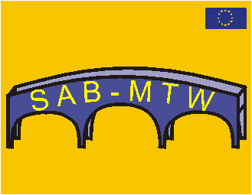

1st Thematic Workshop
School and Business – Making Transition Work / SAB-MTW
Proposal for the programme:
Saturday, 7.12.2002

The STVG hearty invites you to take part in the workshop:

Role of the members in the network SAB-MTW

Organisational matters:

Place: Steirische Volkswirtschaftliche Gesellschaft
Freiheitsplatz 2/3
8010 Graz
Tel: 0043/830260-32
Time: Saturday, 7.12.2002, 9.00 – 12.00; 14.00 – 18.00 o’clock
Lunch: Stern, Sporgasse 38
Dinner: 19.00 o’clock, Glockenspielkeller, Mehlplatz 3
Rooms: Pension Teuschler, Mariatrosterstraße 12, 8043 Graz
Tel: +43/316/321448
http://www.ausflugsziele.at/hotel-teuschler.htm

Contents:
- Who are our current members in the network?
- What role do members have in the network?
- What use can the network have for members?
- What activities have to take place for members?
- How can we attract new members?
- Information from members
- How can the communication/interaction between partners/members take place?
- Preparation of information for the ICT-Workshop

We are looking forward to meet you in Austria!
II. Participations:

Austria: | Great Britain: | Poland:
Sabine Fritz | Ken O.Turner | Czeslaw Noworol
Andrea Graf | Michael Wharton
Peter Härtel
Gundi Kanape
Renate Kremser

III. Protocol

1) Welcome:

Mr. Härtel gives a hearty welcome to all participations of the workshop and thanks Michael for the initiation of the workshop. The 2 main topics of the workshop shall be:
- How can we reach our target groups?
- What benefit can we offer to our members

2) Expectations of the participations:

The participations write down on moderation-cards 2-3 expectations they have in the day. When will the goal of the day be reached for them?

Summary of expectations:

Some of the expectations below might also belong to a second category.

Get offers for members | Enlargement of the network: | Exchanging ideas | Attract new members | Structural working schedule | Action plan
some idea, how “old” and “new” members could help us to reach our project goals | to have a view for the enlargement of the network | plan for concrete offers on different ways: internet, publications, projects school- world of work and so on | a menu of activities, which can attract new members (and which are interesting for members now) | a realistic structure which will enable an effective membership to help the partners achieve the contract with EC i.e.: Targets, indicators, expected outcomes | at least one activity for each of us (and other partners) topic, a goal, what, when, how to report)
find interesting tasks in the project that make it interesting for others to take part | national sub-net of the SAB-MTW / links | to go away with a brief to design the appropriate technology for an expanding network that will have real value to young people, teachers, parents, administrations an business | to find topics which fit to the project | to create an action plan | my role as a member
Possible course for members out of Comenius 2.2 | different languages | why should a young person in “nether wallop” find SAB-MTW valuable to consult, come back, join? | what might be interesting for other members/partners |  | to know my part in the project
How could we join the universities Career Centres and how we can state their role in SAB-MTW | how we can co-operate with existing nets, for examples EURES or NRCVG | Changing ideas with other members + experiences |  |  | to be responsible for a special topic: to find or get a task
what we can offer in the net to attract the members to join us and develop the idea of SAB-MTW |  | Get new ideas for my work with “users” from the “outcome” |  |  | to create an action plan

Out of the named expectations 2 main expectations are mentioned:
New co-operations & services (one-way / two way communication)

Structure

Output / Result
Benefit

New co-operations and services have to be build.
Some people might be users (only the network gives information to them / one –way communication)

Others will be members and participate active (two-way communication)

To know about the services is important for the construction of a structure. The structure is important for the establishment of co-operations.

The result / output of the discussion of the 2 main expectations shall be a clear idea about the benefits for users in the network.

3) Lead-Speech Michael

Michael speaks about his concept about a structure of the network and is making it visuable by the following picture:

AT
FR

IM10

NETWORK

7 Partners, 10 Institutions: 2 persons / institution = 140 people

Explanation of the picture:

If every partner (first line) brings in 10 institutions (Institutional members – IM 10 -second line) and in every institution work two persons in the project we will have at once 140 members for the network.

Michael speaks about his paper for evaluation, especially of point 2.1 - 2.4. The whole paper on evaluation you can find in the internal platform. After this workshop the indicators for 2.3 of the management concerning the members shall be clear. It is important for him to set up a system with this workshop.

Points of attachment in the discussion of the group:

- 1st step is the collection of project, 2nd step to let people know about the database (PR)
- In case-studies in the database there is not enough input. There has to be a decision what information about the case studies will be public.
- Service can be, that the projects are evaluated, provide an expertise
- To gain people can only be over the use of the network for them. It is important to create an added value. To get a feedback after a project can be one use for co-ordinator of past projects.

4) Presentation Renate

  - Actual Situation Members / Role in the proposal

Code | Institution | Contact-person | Role / task in the proposal 1st of March 2001
AT | Päd. Institut des Bundes in der Steiermark | Dr. Erwin Kämmerer | - Exchange of experiences  - Initiation of new projects
AT | Hauptschule Neuberg/Mürz | Hildegund Kanape, Sabine Fritz | - Collecting and documentation of projects
AT | Schul- und Ausbildungsberatung | Dr. Heidi Hudabiunigg | - Collecting and documentation of projects  - Initiation of new projects
AT | Ared Unternehmens-  und Regionalberatung | Johannes Franek | - To bring in the school-network of the project “CHOICE” and “offic(e)”  - Participation in the conception of the network as well as in the whole project-management
AT | Mag. Ingrid Weger | Vienna Business School  HAK/HASCH Augarten | - Collecting and documentation of project  - To bring in further network-partners
AT | Dr. Günther Dichatschek | Hauptschule Kitzbühel | - Collecting and documentation of projects  - To bring in further network-partners especially in the field of equality of chances  - “Sonderpädagogik”, To bring in new network-partners
AT | Ing. Mag. Thomas Hrastnik | Volkswirtschaftliche Gesellschaft Österreich | - Exchange of experiences  - Initiation of new projects
AT | Dr. Gerhard Riemer | Industriellen Vereinigung | - Exchange of experiences  - Initiation of new projects
AT | Dr. Horst Lattinger | Landesschulrat für die Steiermark | - Exchange of experiences  - Initiation of new projects
IT | Stefania Putzu | Instituto Comprensivo di scuola manterna elementare e media-CABRAS | - Collecting and documentation of projects  - Establishment of a new network-node in Italy
IT | Antonio Manca | Istituto comprensivo di scuola materna, elementare e media | - Collecting and documentation of projects  - To establish a new network-node in Italy
ES | Valentín Gandasegui Ruiz | Instituto de Ensesenaza | - Collecting and documentation of projects
GB | Prof. Kenneth O Turner | Elizabeth Hughes Hull, University of Cambridge | - Evaluation  - Enlargement of the internet-application
HU | István Vanyó | Eötvös József Gimnázium | - Collecting and documentation of projects.

  - Potential new members

Code | Institution | Contact-Person | Role / task in the network
AAT | BHAK/ BHAS Grazbachgasse | Mag. Andrea Graf | ?
DE | Senatsverwaltung für Bildung, Jugend und Sport, Berlin | Rudolf Hirsch-Mirre | ?
ES | José Ramón Pérez Díaz | Ciudad Tecnológica Valnalón, c/Hornos Altos s/n | ?
ES | Miguel Angel Caldevilla | Formation Profesional Viva | ?
FI | Vantaa Vocational Institute, Social and Health Care Department | Kirsi Nedelman | ?
FI | University of Kuopio Career Services | Tapio Antonnen | ?
FR | College “Les Aurains” | Marc Thierry | ?
GB | Pinewood School | Graham Rodbard | ?
PLN | Career centres |  | ?

Promise from Slawek after personal contacts:

Until March 2003 there will be established a new polish members in the network:
    - Career Centres
    - Association of Polish employers
    - Departure for labour policies of the ministry of labour
    - Centre of Careers
    - National agency Socrates Poland
    - National agency Leonardo Poland

  - 3 important questions for the workshop

1. What is the use for members? | 2. How can we attract new members? | 3. How can we keep the members in the network?  (Keep on running)

5) Use for members:
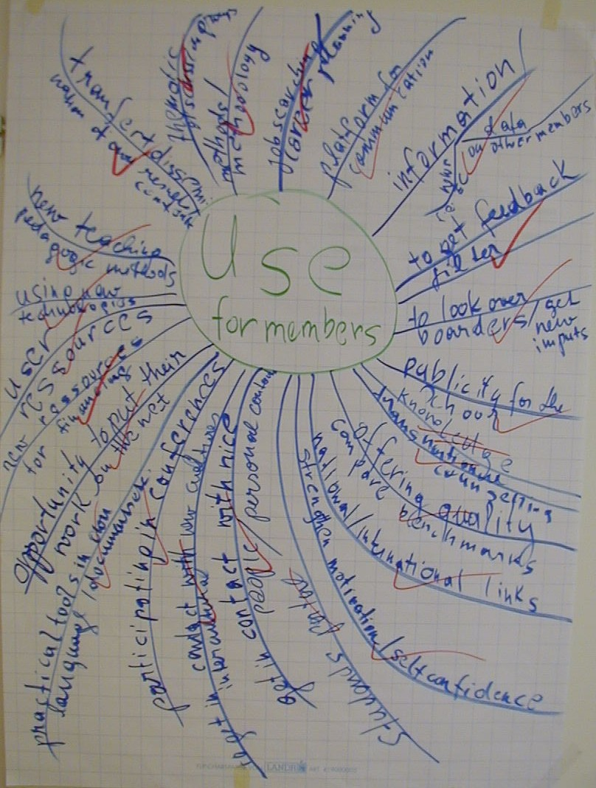

Method used: Brainstorming, Collecting of ideas on a flipchart with
a mind map. In a first step not the quality but the quantity
of the ideas is important. No ideas is a bad idea,
maybe just and unusual one. Spinning is allowed.

Result: 25 ideas for potential use for members

a) Analysis and structuring of the ideas found

Out of the ideas 7 themes, that fit together can be build:

- Inter-cultural / personal contacts / look over the boarders / participate in Th. Conferences
- Quality / Benchmark / Personal skills / Self-confidence / Feedback / Career planning
- Technical offers / Students portal / Virtual conferences / Opportunity to put work in the net / Inter-national links / User resources / Job searching
- Pedagogical offers / Trans-national counselling / Practical tools in own language / Methods / Methodology / Curriculum–influence / Case- studies
- New financing / Sponsoring
- Public information / Publicity for school / Transfer / dissemination of own results

Provide and share expertise

b) Working groups :

2 teams are build to make working plans for the above named 7 questions

Working group 1: Working group 2
Andrea Michael
Härtel Renate
Ken Sabine

Slawek
Questions: I,III,V,VII Questions: II,IV,VI

c) Results of the working-groups:

Results working Group 1

What? | Who? | When?
I. Intercultural personal contacts:
language: members / partners  a) Contacts by project partners (A)  b) Build a local sub-net (Partners as facilitators / direct contacts) (B) | Leaders of the 7 partner-institutions  Helpers | From now on (A)  (B) By the 2nd Conference
III. Technical offers
Platform (Lotus Notes, Disus, Webbaords)  Offers:  - Links  - Contacts (information, people)  Most important is:  To bring life to the platform |  | From January 2003  Pilot version before March 2003  Example:  http://www.nrich.maths.org.uk
V. New financing
Business NGO

National Structure

Sponsoring

Results Working Group 2

What? | When? | Who?
II. Quality

1) Quality benchmark  1. idea:  a) Members: build peer groups: send out form of transferability to members and ask for comment of 2-3 projects  b) Users: in the database shall be a possibility to download the form transferability so they can say their opinion to the projects | now | Partner / co-ordinator
2. idea:  Development of portals / discussion forum: one can put in his ideas, methods, others have chance to say after trying out what they think about the idea.  Additional thoughts:  - How to become a member: Possibility on the homepage  - Shall parts of the discussion forum be open (without password)?  - Problem of language: Use translation programmes like AltaVista?  - Games for members? | After ICT-workshop
2) Personal skills/ Self confidence/Feedback

1. idea:
Feedback to ideas through the portals. Partners are asked to start to put news on it

Additional thoughts:
- There needs to be a responsible person to keep discussion forum lively
3) Career planning:  links about career-planning (job searching machines) in different partner countries | Soon: e-mail to partners and members
IV Pedagogical methods
1) Trans-national Counselling  1. idea:  Links to websites in all partner countries  2. idea:  Curriculum  What do they do in vocational guidance in 7 partner countries: Look to database Eurydice  http://www.eurydice.org/  3. idea:  Every partner shall write at least one page about the vocational guidance in his country  Practical tools / methods:  1. idea:  handbooks / guidelines:  members could document in one page, what methods they use in vocational orientation, etc. in their lessons, when working with young people  the results for every age and every type of school in all partner countries could be collected in a summary  - in general : curriculum  - methods used  Additional thoughts:  - For the presentation of each school can be used pictures as symbols (brick)  2 ) Language:  Little dictionaries of vocabulary in every partner language can be in the database for vocational orientation (AK Dr. Stiegler, Austria)  3) Resources:  1. idea:  To give a booklist in the database of interesting books used to the theme in each partner country | January | Pilot-version: Sabine/Renate
VI Public information
1) School publicity  Used as a statement  2) Transfer / dissemination  1. idea:  Through personal contacts and homepage  2. idea:  Need to belong to other existing networks:  Each partner shall make a list, what important institutions in his country work on the theme. We could install their link on our homepage, they could install our link on their homepage  3. idea:  Contact institutions, that work with school, they shall send out information | Links in 3rd project year  3rd project year

6) Additional information:

- Date for the ICT-Workshop:

Virtual Conference MO, 13th of January:

Workshop in Cambridge: 14,15,16th of February:

- Idea to create some kind of diploma for members who work for the network
- All working papers (like tables: actual situation members, potential new members, etc) to the workshop you can find in the internal platform

Thank you for participating in the 1st Thematic Workshop of SAB-MTW!

© Minutes of Workshop by Renate Kremser

