SAB – MTW / School and Business – Making Transition Work
Reference number: 89730-CP-1-2001-AT-COMENIUS-C3. Duration: 3 years
Co-ordinator’s name and e-mail address: Styrian Economic Society, Dr. Peter Härtel, ph@stvg.com
Network website: http://comenius.stvg.at
Thematic area: School and the world of work (intersections and bridges between school, training and the vocational and professional world)
Main objectives:
- Creating more effective transition channels between initial training on the one hand and further training and vocational paths on the other hand
- Appraisal, dissemination, transfer of results derived from COMENIUS projects, other European measures and other activities in the area of “School and the world of work”
- Securing, arranging, maximising and making use of the results in the general European context
- Developing transferable guidelines for action for the professional integration of young people
- Comprehensive exchange of experience and networking between stakeholders, experts and institutions.
Target Groups:
- The target group basically includes all the young people and stakeholders at the intersections between school and the world of work
- Direct target groups of the network are i.a. those who work professionally and responsibly with young people at these intersections– teachers, entrepreneurs, social partners, policy makers, etc.
Main activities and types of activities:
  - Full inventory of all past and on-going COMENIUS projects and of further European and other activities/projects in the area of school and the world of work.
  - Comparison, analysis, assessment and setting up of examples of best practice
  - Development/dissemination of documentation, materials, concepts for concrete implementation in teaching.
  - Thematic conferences, relevant workshops and meetings
  - Promoting reference projects for translation into other European training and vocational systems
  - Setting up and on-going maintenance of a growing and comprehensive Internet-data base.
  - Concurrent internal and external assessment, assistance to self-assessment and ex-post evaluation
  - Acquisition of further network members and promotion of a structured exchange of experience
Main outcomes:
- Each phase will include collecting and recording around 50 projects in the thematic area of “School and the world of work”
- The conditions for transfer into other training systems have been defined and are available in several languages
- Internet applications for the exchange of experiences (at European level) between users, as well as basic offers from the network, including a project data base, have been set up (around 30 new users in each phase).
- Concurrent external and internal assessment are in place, self-assessment processes are being implemented.
Partnership:
Austria (AT, co-ordinator): Germany (DE): Spain (ES): France (FR): Finland (FI): United Kingdom (UK): Poland (PL):
Associated Members: Austria: 9, Italy: 2, Hungary 1, United Kingdom 1.
The 1st European Conference
of the Comenius-network School and Business
Making Transition Work: SAB-MTW

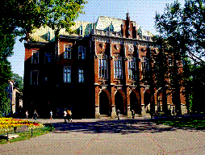

Collegium Novum of the Jagiellonian University

All the correspondence concerning the conference shall be addressed to the secretary of the conference:

Career Center UJ
ul. Straszewskiego 27 pok. 4
31-113 Krakow, Poland
tel/fax: +48(0) # 12 4311328
e-mail: careers@theta.uoks.uj.edu.pl

The organisers ask all the colleagues interested in participation in the conference to fill in the attached registration form and hotel reservation form, and send it back to the organising committee preferably before August 31st 2002.

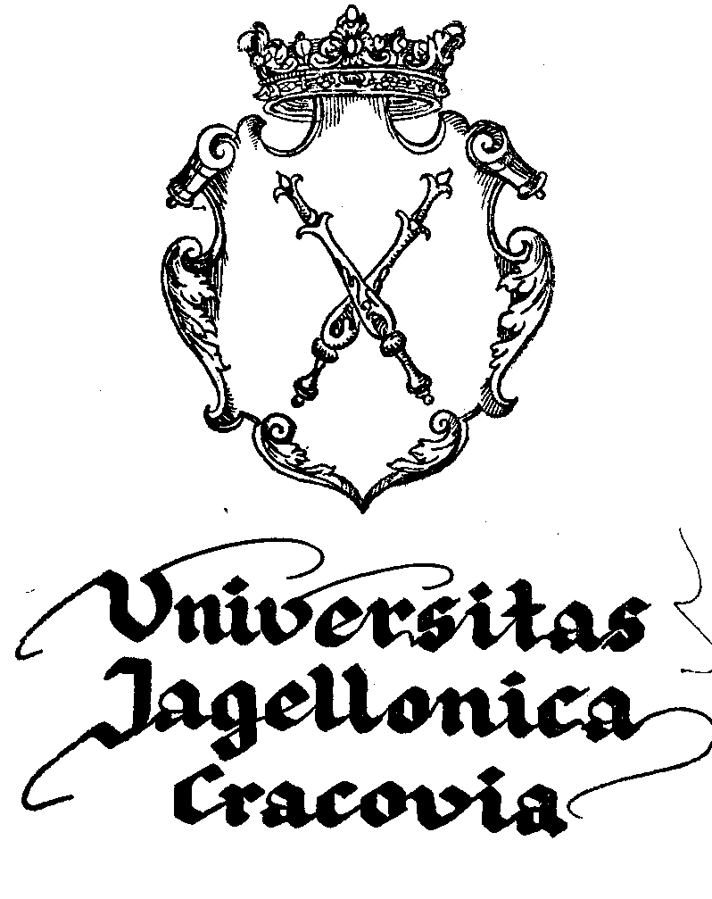

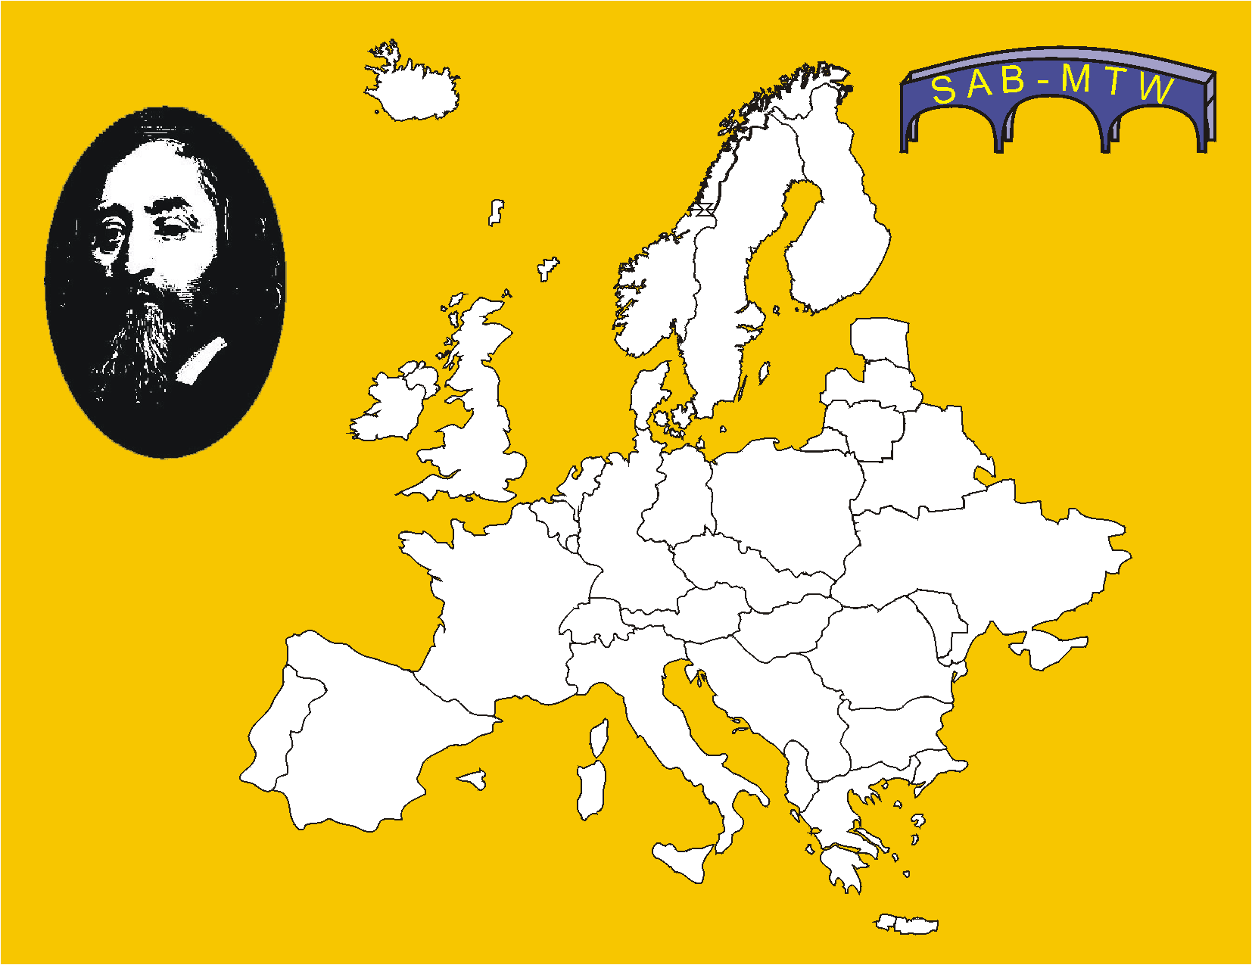

THE CHANGING EUROPEAN WORLD
OF WORK

FIRST EMPLOYMENT

How does school prepare to it?

Jagiellonian University
Krakow, Poland, September 25-29, 2002
Supported by the European Union

