The Conference Announcement and Call for Papers
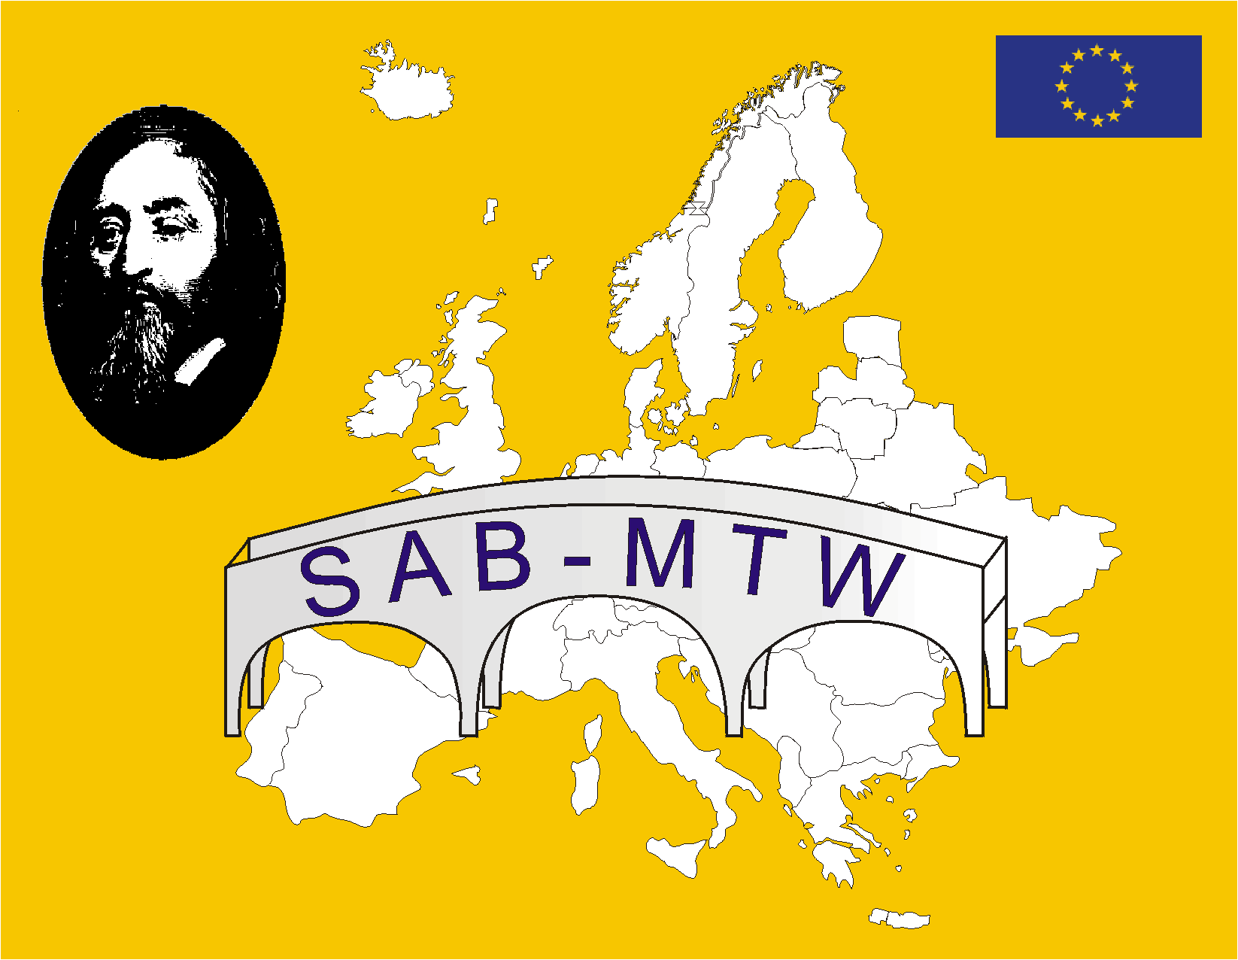

The 1st European Conference on SAB-MTW

The Changing European World of Work

First Employability

How does school prepare to it?
Jagiellonian University
Kraków, Poland, September 25-27, 2002

The conference is organized under the auspices of the Steering Team of the Comenius Project SAB-MTV: School and Business - Making Transition Work and the Authorities of the Jagiellonian University. The Conference will be open to the Scientists and Practitioners interested in the various aspects of youth transition from school to work and Project Partners, Members of the European Network.

Programme
- The First Job in Changing European World of Work
  - The policy in various European countries in order to improve SAB-MTW
- Best Practice in School
  - World of Work – what it is? The school perspective
  - How to get first step in the Labor Market?
  - University Career Centers
  - National centers for vocational information and career development
  - Best projects: exchange of information and best practices
- Transnational Vocational Guidance
  - The European Challenge
  - Equal opportunities in transition from school to the working world
  - Graduates in or out of the TVG?
  - The role of vocational interest and ability tests in TVG
- Round Table Session

Deadline for paper submission: September 15, 2002
The papers of presentations should be submitted in an electronic form, preferably by e-mail. Typed single spaces, Arial 12 p.
Language: the official language of the Conference is English.

Organization: Ms. Agnieszka Meres, careers@theta.uoks.uj.edu.pl

Accommodation
Hotel: about 100-150 Euro (incl. breakfast)
Conference Fee: 250 Euro, should be paid to the following bank account:
Bank PEKAO SA, III ODDZ. Kraków, Street: Szpitalna 15, Account Number: 10701193-592-2311-0500978
SWIFT PKOPPLPWKR3,Czeslaw Noworol: (SAB-MTW), Unit of Psychometrics & Research into Quality of Higher Education Processes, Institute of Management, Jagiellonian University, Jozefa 19, 31-056 Krakow, Poland

