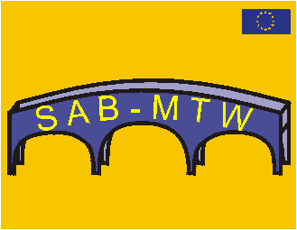

1st ideas for the program of the
Final Thematic Conference SAB-MTW
3rd and 4th of June

Wednesday, 2nd of June 2004
19.00 Welcome party 2004

Thursday, 3rd of June 2004
10.00 - 17.00
- Key speech of an international specialist “School and Business”
- Presentation of the results of SAB-MTW
- Best practice in: Austria, Finland, France, Germany, Poland, Spain and in the United Kingdom.
- workshops for special themes of transition:
i.e.
- actual questions of transition between school and the world of work in change
- people with special needs
- equal possibilities men and women
- from early transition until transition from university
- school-municipality
- special questions considering the enlargement of the European Union
- Presentation and final certifications for the project Synergy manager
- Perspectives for further networking and national and trans-national dissemination of SAB-MTW

Friday, 4th of June 2004
10.00 – 16.00
Emphasis of transition in the 7 partner countries of SAB-MTW
Different countries – different methods- different languages

