SAB – MTW / School and Business – Making Transition Work
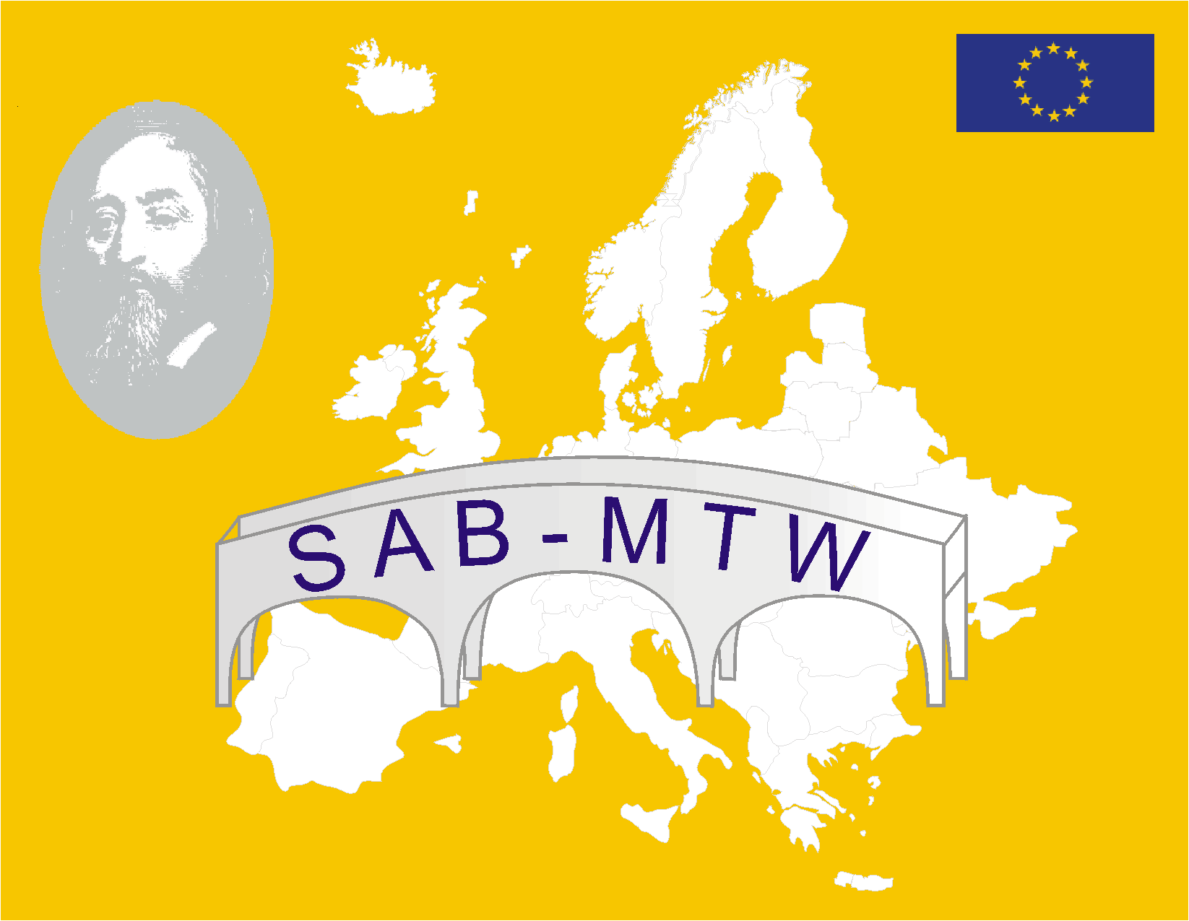

Reference number: 89730-CP-1-2001-AT-COMENIUS-C3

Duration: 3 years

Co-ordinator’s name and e-mail address: Styrian Economic Society
Dr. Peter Härtel, ph@stvg.com

Network website: http://comenius.stvg.at

Thematic area:

School and the world of work (intersections and bridges between school, training and the vocational and professional world)

Main objectives:
- Creating more effective transition channels between initial training on the one hand and further training and vocational paths on the other hand
- Appraisal, dissemination, transfer of results derived from COMENIUS projects, other European measures and other activities in the area of “School and the world of work”
- Securing, arranging, maximising and making use of the results in the general European context
- Developing transferable guidelines for action for the professional integration of young people
- Comprehensive exchange of experience and networking between stakeholders, experts and institutions.

Target Groups:
- The target group basically includes all the young people and stakeholders at the intersections between school and the world of work
- Direct target groups of the network are i.a. those who work professionally and responsibly with young people at these intersections– teachers, entrepreneurs, social partners, policy makers, etc.

Main activities and types of activities:
  - Full inventory of all past and on-going COMENIUS projects and of further European and other activities/projects in the area of school and the world of work.
  - Comparison, analysis, assessment and setting up of examples of best practice
  - Development/dissemination of documentation, materials, concepts for concrete implementation in teaching.
  - Thematic conferences, relevant workshops and meetings
  - Promoting reference projects for translation into other European training and vocational systems
  - Setting up and on-going maintenance of a growing and comprehensive Internet-data base.
  - Concurrent internal and external assessment, assistance to self-assessment and ex-post evaluation
  - Acquisition of further network members and promotion of a structured exchange of experience

Main outcomes:
- Each phase will include collecting and recording around 50 projects in the thematic area of “School and the world of work”
- The conditions for transfer into other training systems have been defined and are available in several languages
- Internet applications for the exchange of experiences (at European level) between users, as well as basic offers from the network, including a project data base, have been set up (around 30 new users in each phase).
- Concurrent external and internal assessment are in place, self-assessment processes are being implemented.

Main events (particularly in the first project phase):
The activity of the network is complemented by annual meetings of the transnational steering team, annual thematic conferences and 2 thematic workshops. The first thematic conference, on the topic “The Changing European World of Work – How does school prepare to it ?“, will take place late in September 2002 in Poland.

Expected impact:
A number of Comenius projects - and other European activities - have dealt with the topic “School and the world of work“ in the past. The outcomes and experiences deriving from these projects and activities will be collected, recorded and made available to a broader public for the first time. This and the further network activities will lead to the following project outcomes :

- for young people: better vocational integration as a pre-condition for successful and lifelong learning. This could lead to a decrease in unemployment among young people.
- for teachers, advisers i.a: access to concrete information, tools, materials, supports, project guides, for appropriate use in schools, institutions, businesses;

for entrepreneurs and trainers in businesses: businesses eventually hire young people who hold the orientations and qualifications required by the business itself;

- for all the network members: a European-wide (including the accession countries) communication network of experts, decision-makers and stakeholders, supported by a data base.

Partnership:
Number of partner institutions and countries (including the co-ordinator): 7
Types of institutions: Austria (AT, co-ordinator): association of public interest ; Germany (DE): research institution; Spain (ES): secondary school; France (FR): secondary school; Finland (FI): secondary school; United Kingdom (UK): private business ; Poland (PL): institution for higher education

Number of associated members: 13 (Austria: 9; Italy: 2; Hungary: 1; United Kingdom: 1).

